- Enabled LISP Debugging, to enable DraftSight to inform for file path or compatibility issues, if any.
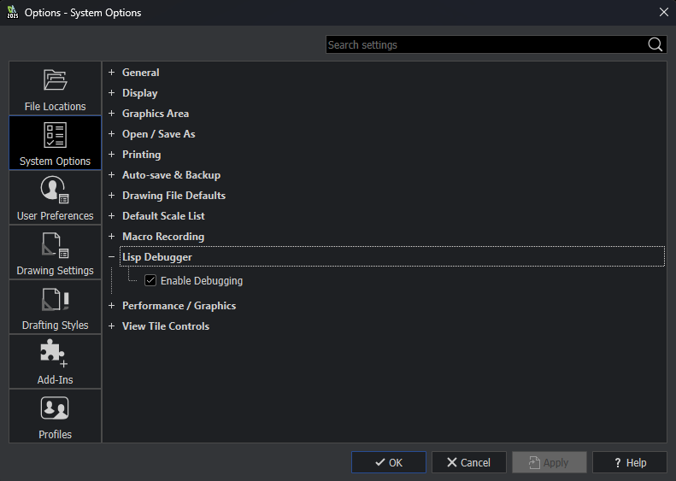

- Created a trial file with Scaled Dimensions as shown below for test. Selected the Scaled Dim.
(At the end of the test run of the code, a pop up should reveal the scaled individual dim that are no 1:1 and highlight them)
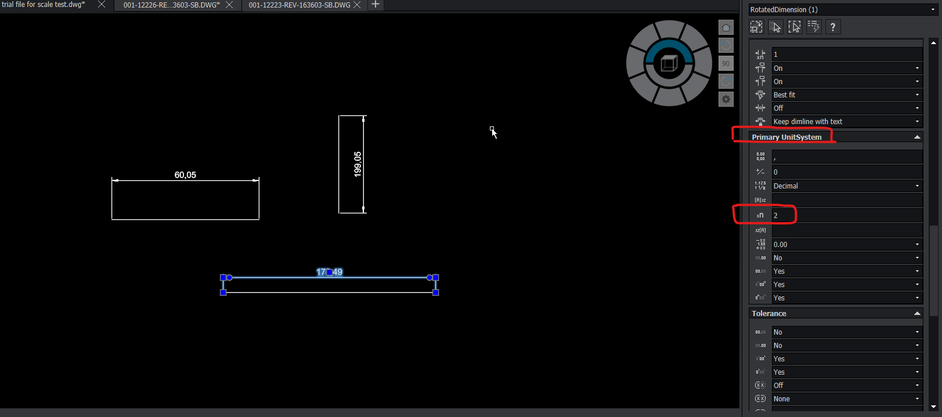

- Tools > Load Application > Select the AUTO LISP File Saved in Outsource Folder under DraftSight LISP folder to run the application and check efficacy.
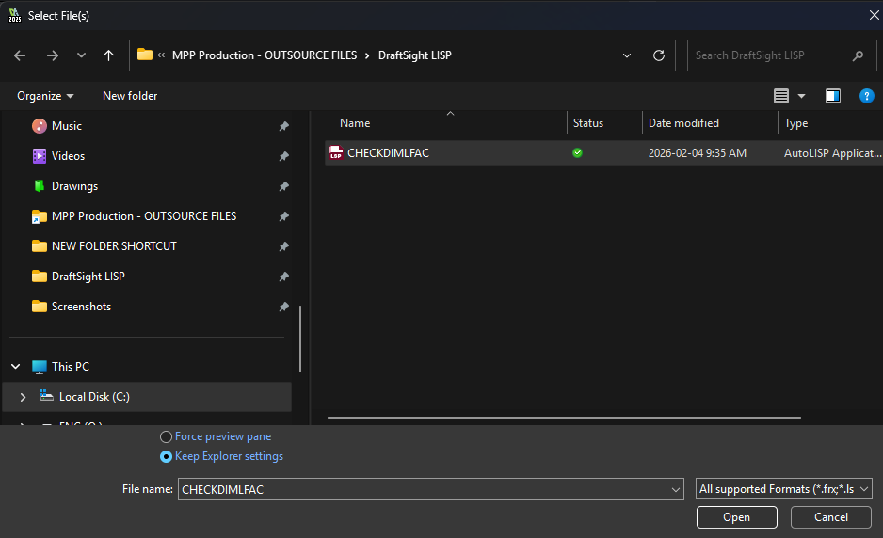

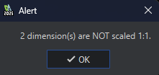
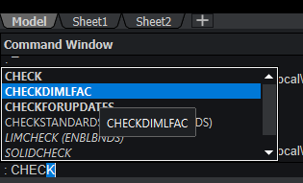
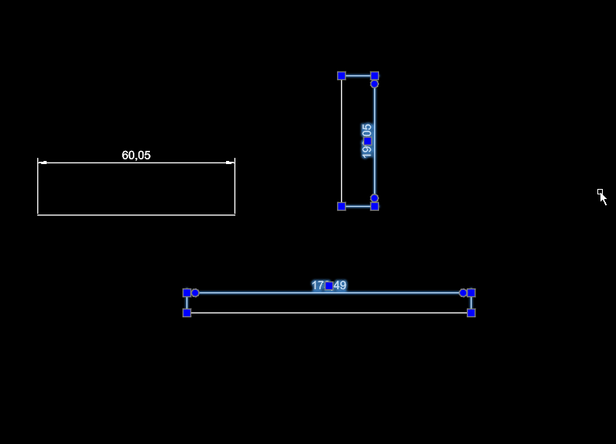
- Enter Command>CHECKDIMLFAC > Popup and Highlighted Dims alert the user.

Logic Sequence
Load Visual Lisp Interface (vl-load-com) > Saves each dimension with readable properties (not possible in LISP interface) > Run If loop to Check and compile Scaled dim saved under DIMLFAC function (Linear Scale Factor shown in properties tab on the right) > Displays results.

- Enable this command on Startup, so it automatically loads every time we open a drawing on DraftSight. Tools> Add Ins
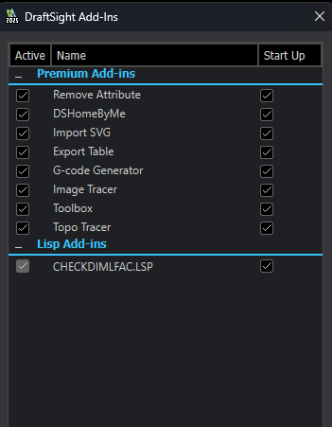
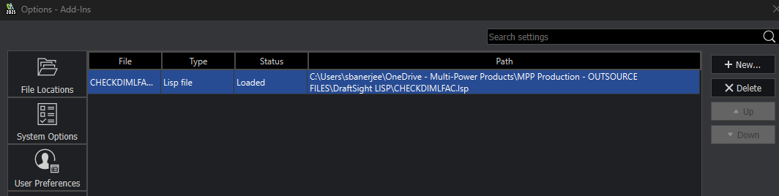

Process to create a toolbar button to run the command

- Tools>Customize UI>Command Tab>Add a New Command Name=> CHECKDIMLFAC >Enter in Command String=> ^C^C_CHECKDIMLFAC (shown below)> Icon can be selected from the options given on the icon explorer option on the right.
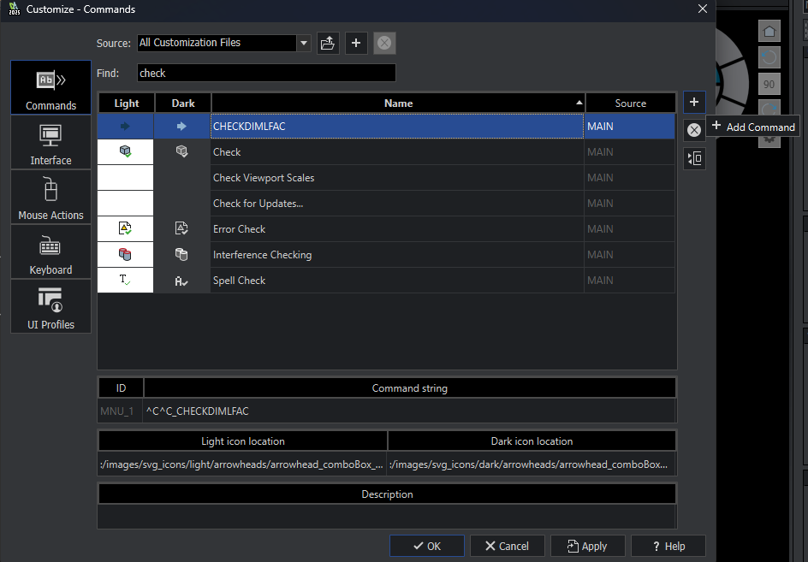

- Tools>Customize UI>RMB> Add Toolbar
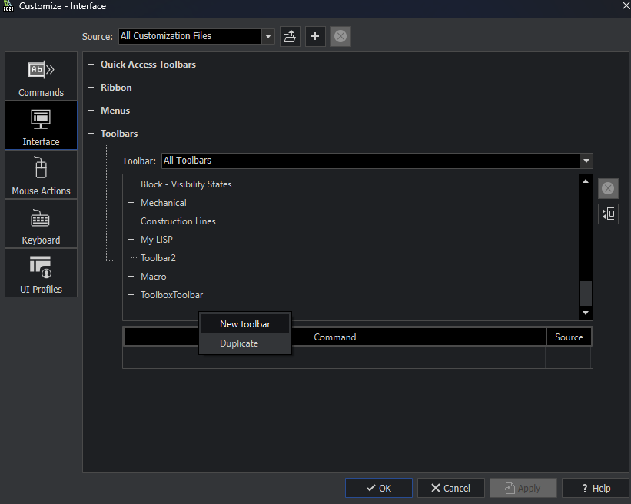
- Rename as MYLISP > Add DIMLFAC in the empty entries w/ new entry dropdown on RMB > Enter previously saved command CHECKDIMLFAC from Dropdown in Command String.
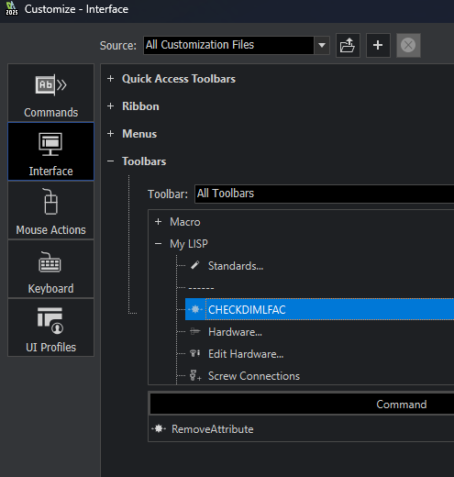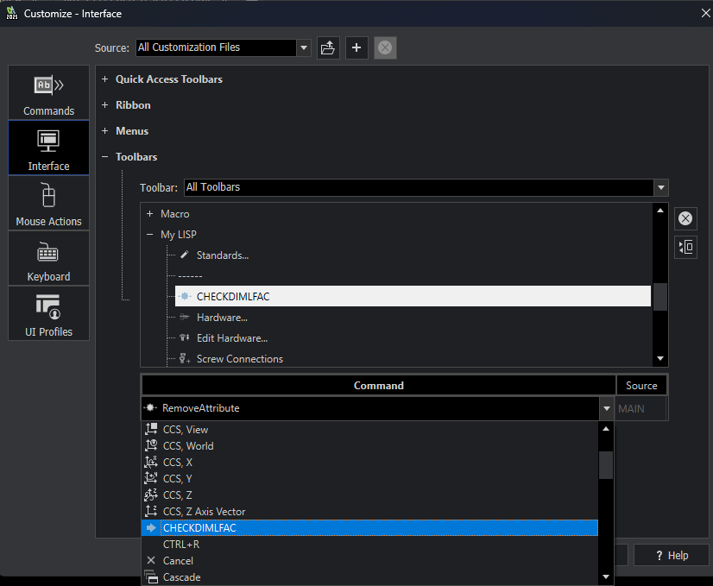

- RMB on empty space on the Toolbar area to activate the MY LISP toolbar. This adds the toolbar on the workspace.
